# 一、电脑与N210的连接

用一条交叉网线（但事实上是一根直通线，估计在USRP N210内部电路进行交叉），连接电脑与N210的网口（Gb ETHERNET）

电脑网络设置网卡的IP地址如下：其中192.168.10.1是电脑本机的IP地址，而192.168.10.2是USRP N210的缺省网址。

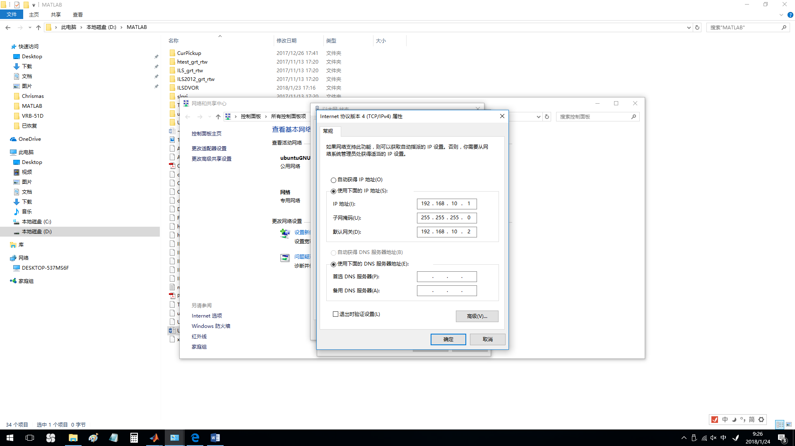

**Windows® 7 Setup.**Configure the NIC for your USRP® hardware by performing the following Windows task workflow.

1. Select **Control Panel** from the Windows icon in the lower left corner of your monitor.

In the upper right-hand corner, make sure **View by** is set to Category.

1. Select **Network and Internet**.

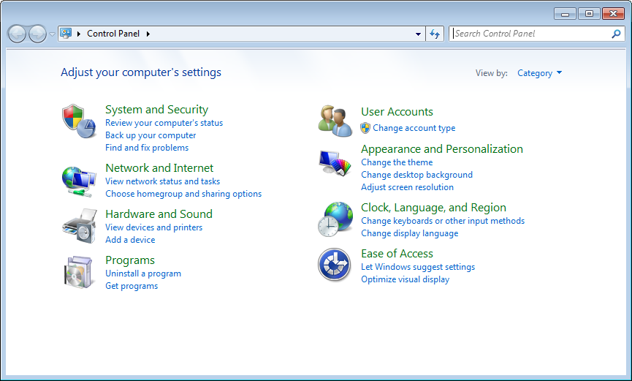

1. Select **Network and Sharing Center**.

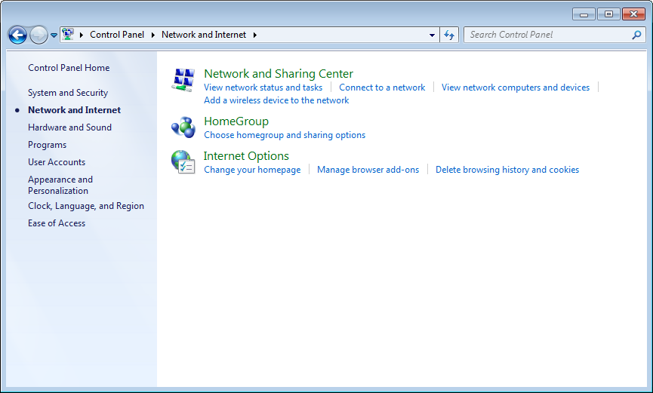

1. Select **Change adapter settings** on the left sidebar.

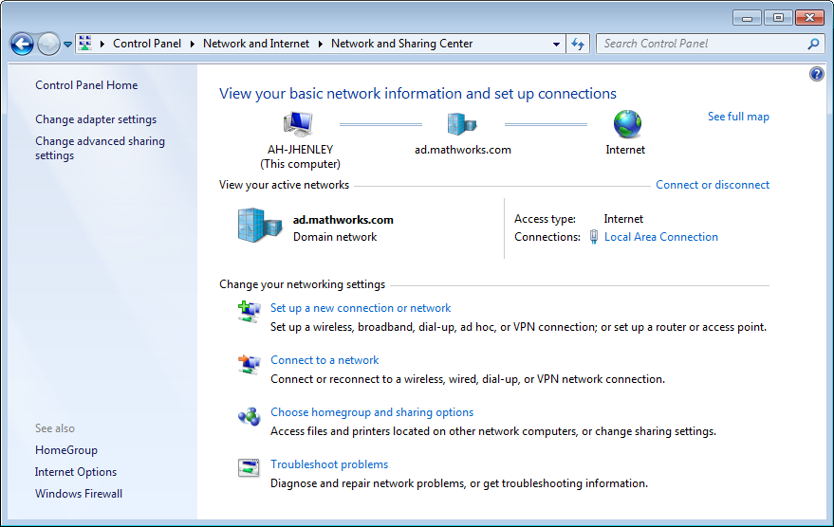

1. Right-click the local area network connection that is connected to the USRP® device to get the popup menu. Select **Properties**.

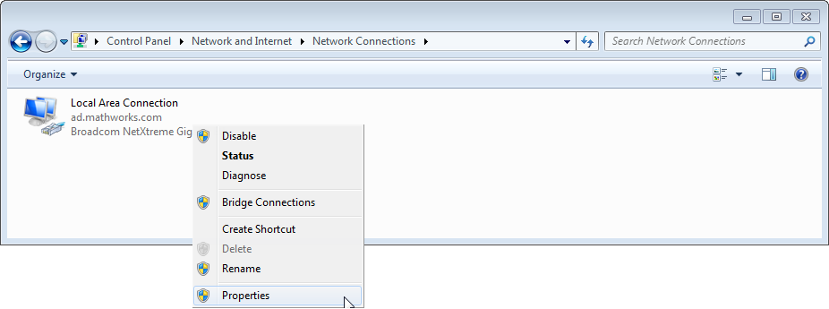

### Dedicated NIC

If an unused NIC is available, the local area connection is displayed as "Unidentified network".

1. On the **Networking** tab of the dialog box, clear options **Clients for Microsoft Networks** and **File and Printer Sharing for Microsoft Networks**. These services might cause intermittent connection problems with the USRP® radio sometimes.

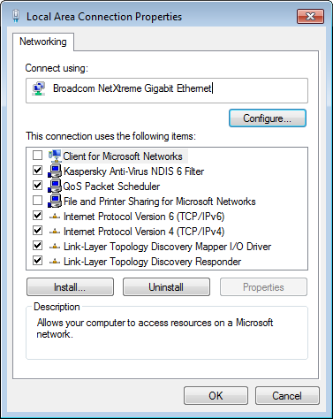

1. Double-click **Internet Protocol Version 4 (TCP/IPv4)**.

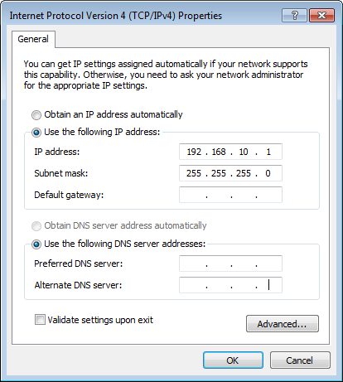

1. On the **General** tab, select **Use the following IP Address**.
2. Set host IP Address to 192.168.10.*X*, where *X* is any number from 1 to 255 except 2.

If your USRP® radio is on another subnet (the first three octets of the IP address field are not 192.168.10), then the IP address that you enter here must have the same subnet number. See [Check Subnet Values on Host and Radio](http://cn.mathworks.com/help/supportpkg/usrpradio/ug/support-package-hardware-setup.html#bud4hbq-7).

1. Leave the subnet mask set to default (255.255.255.0).
2. Click **OK**.
3. Host configuration is complete. Continue to [Step 3.Verify Hardware Connection](http://cn.mathworks.com/help/supportpkg/usrpradio/ug/support-package-hardware-setup.html#bud4hbq-1).

# 三、MATLAB的设置

MATLAB中中需要安装USRP的专用硬件支持包，在“获取硬件支持包”中找到USRP的相关项，进行安装。或下载后手动安装。

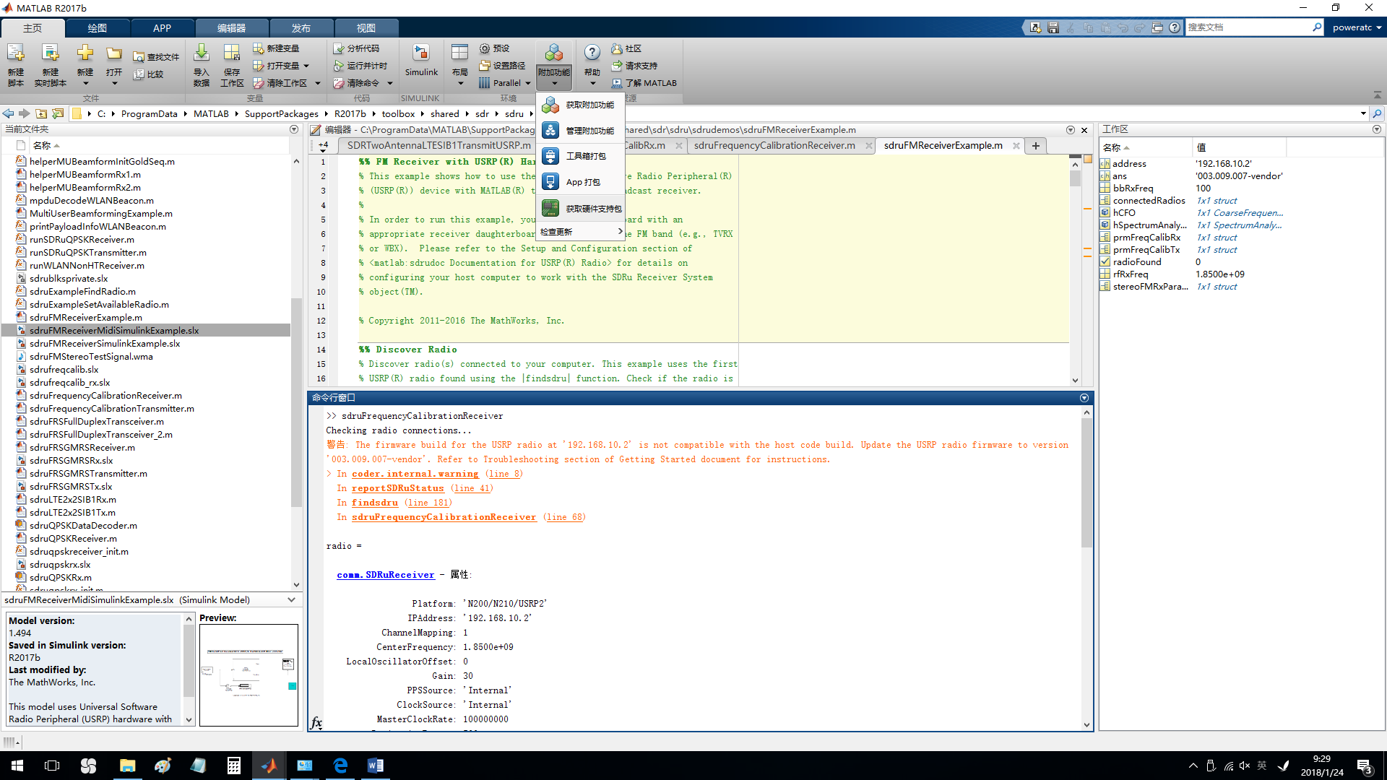

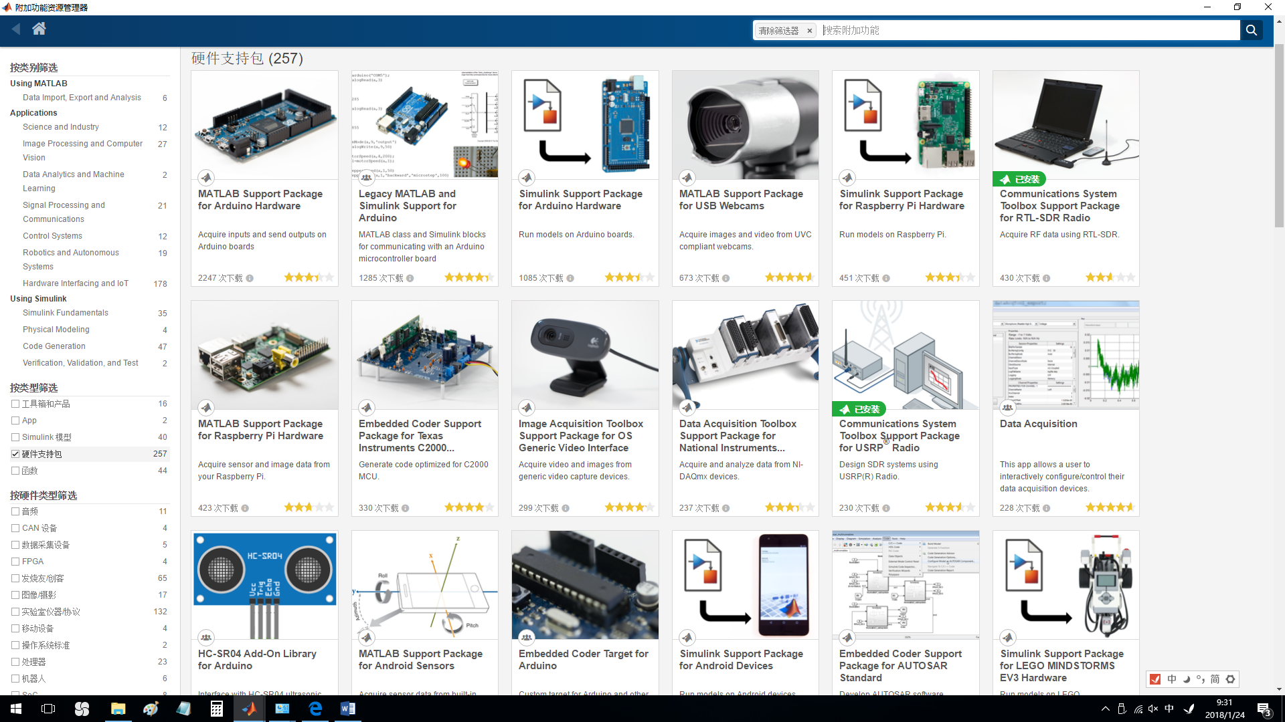



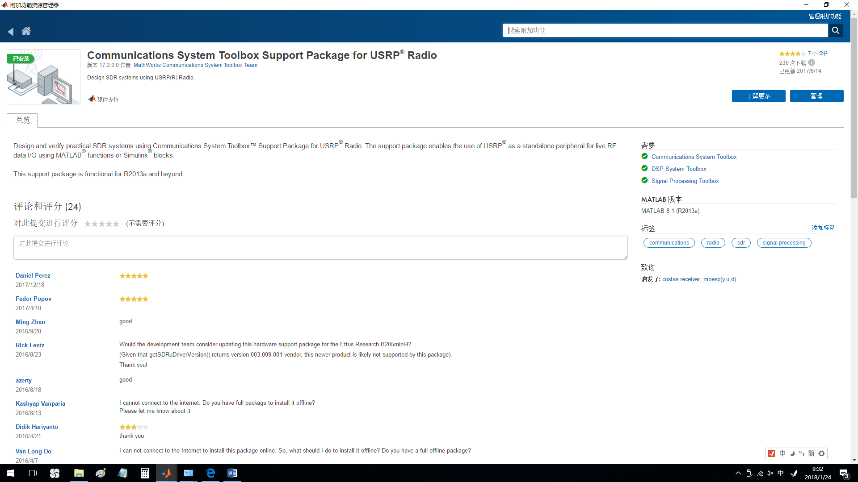

# 四、找到这些支持包在电脑上的安装位置

C:\ProgramData\

MATLAB\SupportPackages\R2017b\

toolbox\shared\sdr\sdru\sdrudemos

# 五、检查USRP FIRMWARE版本号

由于MATLAB与USRP通信需要一个特殊的UHD驱动，所以FPGA的版本号应兼容。

# 六、上MATLAB网站获取技术支持

<http://cn.mathworks.com/help/supportpkg/usrpradio/ug/support-package-hardware-setup.html#buozv_z-50>

#### Step 1. Check Firmware

The UHD™ firmware on the USRP® radio hardware must match the UHD™ firmware on the host computer. You may need to upgrade your radio’s firmware. You can find the latest supported UHD™ version in the current Release Notes.

To check your radio’s firmware, enter the following function at a MATLAB command prompt:

getSDRuDriverVersion

For more information about this function, see the reference page for [getSDRuDriverVersion](http://cn.mathworks.com/help/supportpkg/usrpradio/ug/getsdrudriverversion.html).

If you do need to upgrade the firmware, see [USRP® Radio Firmware Update](http://cn.mathworks.com/help/supportpkg/usrpradio/ug/update-usrp-radio-firmware.html).

### Step 4. Verify MATLAB Connection to USRP® Radio

This step helps you to verify that MATLAB can communicate with the USRP® radio using the support package. If you get a successful status, it means that MATLAB can communicate with the USRP® radio and the radio is ready to be used.

1. Type the following at the MATLAB command line:

radios = findsdru

The variable, radios, is a structure that contains information on the USRP® radios connected to the host computer. If the function finds one or more radios, it returns an array of structures.

* If the function cannot find a radio, MATLAB returns an empty IPAddress or SerialNum field or a status other than Success. See the section on [Common Problems and Fixes](http://cn.mathworks.com/help/supportpkg/usrpradio/ug/common-problems-and-fixes.html) for possible causes and solutions.
* If the function finds one or more radios, MATLAB displays a message similar to the following.
  + Ethernet-connected radio:
  + Platform: 'X310'
  + IPAddress: '192.168.10.2'
  + SerialNum: 'F4BF0D'
  + Status: 'Success'
  + Platform: 'N200/N210/USRP2'
  + IPAddress: '192.168.20.2'
  + SerialNum: '873'
  + Status: 'Success'
  + USB-connected radio:
  + Platform: 'B200'
  + IPAddress: ''
  + SerialNum: 'ECR04ZDBT'
  + Status: 'Success’

# 七、检查和升级固件

### Step 2. Configure Host Computer for Ethernet Connection

### Note

This step is required for Networked and X Series radios. For Bus Series radios, go to [Step 4. Verify MATLAB Connection to USRP® Radio](http://cn.mathworks.com/help/supportpkg/usrpradio/ug/support-package-hardware-setup.html#bueheq_-1).

* [Step 1. Check Firmware](http://cn.mathworks.com/help/supportpkg/usrpradio/ug/support-package-hardware-setup.html#buozv_z-50)
* [Step 2. Configure NIC](http://cn.mathworks.com/help/supportpkg/usrpradio/ug/support-package-hardware-setup.html#bvmu06d)

#### Step 1. Check Firmware

The UHD™ firmware on the USRP® radio hardware must match the UHD™ firmware on the host computer. You may need to upgrade your radio’s firmware. You can find the latest supported UHD™ version in the current Release Notes.

To check your radio’s firmware, enter the following function at a MATLAB command prompt:

getSDRuDriverVersion

For more information about this function, see the reference page for [getSDRuDriverVersion](http://cn.mathworks.com/help/supportpkg/usrpradio/ug/getsdrudriverversion.html).

If you do need to upgrade the firmware, see [USRP® Radio Firmware Update](http://cn.mathworks.com/help/supportpkg/usrpradio/ug/update-usrp-radio-firmware.html).

>> getSDRuDriverVersion()

ans =

'003.009.007-vendor'

需要针对'003.009.007-vendor'这个版本号对FPGA FIRMWARE进行升级。

# 八、如何升级固件

### Why Download New Firmware?

The Communications System Toolbox™ Support Package for USRP®[[1](http://cn.mathworks.com/help/supportpkg/usrpradio/ug/update-usrp-radio-firmware.html#ftn.d118e1837)] Radio uses a specific version of the UHD™ software on the host computer side. If the USRP® radio has a different version of UHD™ firmware installed, you might not be able to communicate with the USRP® radio and use the support package.

### Note

For the Bus Series devices, you do not need to check or update the firmware. It is automatically loaded when the device is plugged in.

You can update the UHD™ firmware using the [sdruload](http://cn.mathworks.com/help/supportpkg/usrpradio/ug/sdruload.html) function.

### Updating USRP® Radio Firmware

Before updating the radio firmware, make sure that the radio is connected to and communicating with the host computer. If not, see [Support Package Hardware Setup](http://cn.mathworks.com/help/supportpkg/usrpradio/ug/support-package-hardware-setup.html).

### Note

Custom firmware image is not supported for X300 or X310.

#### Update Networked Series Radio Firmware

Calling the sdruload function in MATLAB® with the following parameters loads the default images to a radio at default IP address 192.168.10.2:

sdruload('Device','dev')

Depending on which Networked Series device you have connected, replace *'dev'* with n200 or n210.

You can specify additional parameters, such as a nondefault IP address and nondefault firmware and FPGA images. See [sdruload](http://cn.mathworks.com/help/supportpkg/usrpradio/ug/sdruload.html).

#### Update USRP2® Radio Firmware

Calling the sdruload function in MATLAB with the following parameters writes the default FPGA and UHD™ firmware image to an SD card:

sdruload('Device','USRP2')

# sdruload

Load FPGA and firmware images for USRP® radio

## Syntax

sdruload('Device',device)

sdruload('Device',device,Name,Value)

STATUS = sdruload(\_\_\_)

## Description

[example](http://cn.mathworks.com/help/supportpkg/usrpradio/ug/sdruload.html#bud4lno-7)

sdruload('Device',[device](http://cn.mathworks.com/help/supportpkg/usrpradio/ug/sdruload.html#inputarg_device)) loads the default FPGA and UHD™[[1](http://cn.mathworks.com/help/supportpkg/usrpradio/ug/sdruload.html#ftn.d118e11912)] firmware images for device device.

* Firmware images are the UHD™ versions compatible with the Communications System Toolbox™ Support Package for USRP® Radio.
  + If the device is an N2xx or X3xx series radio, this syntax loads the default images to the radio at IP address 192.168.10.2.
  + If the device is a USRP2® radio, this syntax writes the images to an SD card.

You can obtain the compatible UHD™ version number by entering getSDRuDriverVersion at the MATLAB® command prompt.

sdruload('Device',[device](http://cn.mathworks.com/help/supportpkg/usrpradio/ug/sdruload.html" \l "inputarg_device),[Name,Value](http://cn.mathworks.com/help/supportpkg/usrpradio/ug/sdruload.html#namevaluepairarguments)) uses additional options specified by one or more Name,Value pair arguments.

[STATUS](http://cn.mathworks.com/help/supportpkg/usrpradio/ug/sdruload.html#outputarg_STATUS) = sdruload(\_\_\_) returns the status information of the call to sdruload.

**Note**

sdruload uses the uhd\_image\_loader utility or the usrp2\_card\_burner.py Python script provided by Ettus Research® for burning firmware images to the device.

**Warning**

When burning images with the card burner, it is possible for you to overwrite your hard drive. To avoid accidentally overwriting the wrong drive, when using the card burner script, carefully select the correct drive for the radio.

## Examples

### Load Custom FPGA to N210 Device

Load a custom FPGA image to an N210 device and return the status of the operation.

status = sdruload('Device','N210','IPAddress','192.168.30.8',...

'FPGAImage','c:\sdru\uhdapps\images\usrp\_n210\_r4\_fpga\_ex.bin')

Checking radio connections...

Ready to write FPGA image

usrp\_n210\_r4\_fpga\_ex.bin

and default firmware image

to n210 device at 192.168.30.8. Would you like to continue? [yes/no]: yes

Writing images using uhd\_image\_loader ...

==== Start messages from third party application ====

linux; GNU C++ version 4.9.3; Boost\_105600; UHD\_003.009.004-vendor

Unit: USRP N210 r4 (ECR16TEUP, 192.168.30.8)

Firmware image: c:\sdru\uhdapps\images\usrp\_n210\_fw.bin

-- Erasing firmware image...successful.

-- Writing firmware image (0%)

-- Writing firmware image (1%)

.

.

.

-- Writing firmware image (98%)

-- Writing firmware image...successful.

-- Verifying firmware image (0%)

-- Verifying firmware image (1%)

.

.

.

-- Verifying firmware image (98%)

-- Verifying firmware image...successful.

FPGA image: c:\sdru\uhdapps\images\usrp\_n210\_r4\_fpga\_ex.bin

-- Erasing FPGA image...successful.

-- Writing FPGA image (0%)

...

-- Writing FPGA image (99%)

-- Writing FPGA image...successful.

-- Verifying FPGA image (0%)

.

.

.

-- Verifying FPGA image (99%)

-- Verifying FPGA image...successful.

-- Resetting device...successful.

==== End messages from third party application ====

status =

logical

1

## Input Arguments

[collapse all](javascript:void(0);)

### device — USRP® radio 'USRP2' | 'n200' | 'n210' | 'x300' | 'x310'

USRP® radio, specified as a comma-separated pair consisting of 'Device' and a USRP radio device from this set {'USRP2', 'n200', 'n210', 'x300', or 'x310'}.

* If you specify an invalid device, MATLAB responds displaying the list of valid devices.
* If the device you specify does not match the device connected, the error message returned by MATLAB lists the connected device name and prompts you to specify the connected device or to connect another device.
* Additional software must be installed prior to executing sdruload to load firmware for an 'USRP2' radio. For more information, see [Update USRP2® Radio Firmware](http://cn.mathworks.com/help/supportpkg/usrpradio/ug/update-usrp-radio-firmware.html#bun5__a-3).

**Example:** 'Device','n200'

### Name-Value Pair Arguments

Specify optional comma-separated pairs of Name,Value arguments. Name is the argument name and Value is the corresponding value. Name must appear inside single quotes (' '). You can specify several name and value pair arguments in any order as Name1,Value1,...,NameN,ValueN.

**Example:** sdruload('Device','USRP2')

[collapse all](javascript:void(0);)

### 'IPAddress' — IP address where the N2xx or X3xx series radio is located character vector

IP address where the N2xx or X3xx series radio is located, specified as a comma-separated pair consisting of 'IPAddress' and a valid IP address.

**Example:** 'IPAddress','192.168.10.2'

### 'Drive' — SD card drive character vector

Valid SD card drive for USRP2® device, specified as a comma-separated pair consisting of 'Drive' and a valid SD card drive. When Device is specified as'USRP2', sdruload loads the images for a USRP2® radio to an SD card at the SD card drive specified. If you do not specify a value for 'Drive', the function searches for possible SD card drives and prompts you to select one.

This option uses the uhd\_image\_loader utility provided by Ettus Research.

**Example:** 'Drive','S:'

### 'FPGAImage' — FPGA image character vector

FPGA image, specified as a comma-separated pair consisting of 'FPGAImage' and a valid FPGA image file. Use this option to load the FPGA image that is compatible with the UHD version supported by MATLAB and Simulink®.

You can also use this option to load custom FPGA images, including images you generate using the HDL workflow advisor. For more information, see HDL Coder™.

### Note

Custom FPGA image uploading is not supported for X300 or X310.

**Example:** 'FPGAImage','c:\work\fpga\usrp\_n210\_r4\_fpga.bin'

### 'FirmwareImage' — Firmware image character vector

Firmware image, specified as a comma-separated pair consisting of 'FirmwareImage' and a valid firmware image file. Use this option to load the UHD firmware image that is compatible with the UHD version supported by MATLAB and Simulink.

### Note

Custom firmware image updating is not supported for X300 or X310.

**Example:** 'FirmwareImage','c:\work\fpga\usrp\_n210\_fw.bin'

## Output Arguments

[collapse all](javascript:void(0);)

### STATUS — Status of call to sdruload logical

Status of call to sdruload, returned as true if the operation was successful.

# USRP2 USRPN210 烧写

* [编辑](http://mp.blog.csdn.net/postedit/6872533)
* 删除

# Load the images onto the SD card (USRP2 only)

**Warning!** Use the usrp2\_card\_burner.py with caution. If you specify the wrong device node, you could overwrite your hard drive. Make sure that --dev= specifies the SD card.

**Warning!** It is possible to use 3rd party SD cards with the USRP2. However, certain types of SD cards will not interface with the CPLD:

* Cards can be SDHC, which is not a supported interface.
* Cards can have unexpected timing characteristics.

For these reasons, we recommend that you use the SD card that was supplied with the USRP2.

## Use the card burner tool (unix)

sudo <install-path>/share/uhd/utils/usrp2\_card\_burner\_gui.py

-- OR --

cd <install-path>/share/uhd/utils

sudo ./usrp2\_card\_burner.py --dev=/dev/sd<XXX> --fpga=<path\_to\_fpga\_image>

sudo ./usrp2\_card\_burner.py --dev=/dev/sd<XXX> --fw=<path\_to\_firmware\_image>

Use the --list option to get a list of possible raw devices. The list result will filter out disk partitions and devices too large to be the sd card. The list option has been implemented on Linux, Mac OS X, and Windows.

## Use the card burner tool (windows)

<path\_to\_python.exe> <install-path>/share/uhd/utils/usrp2\_card\_burner\_gui.py

# Load the images onto the on-board flash (USRP-N Series only)

The USRP-N Series can be reprogrammed over the network to update or change the firmware and FPGA images. When updating images, always burn both the FPGA and firmware images before power cycling. This ensures that when the device reboots, it has a compatible set of images to boot into.

**Note:** Different hardware revisions require different FPGA images. Determine the revision number from the sticker on the rear of the chassis. Use this number to select the correct FPGA image for your device.

## Use the net burner tool (unix)

<install-path>/share/uhd/utils/usrp\_n2xx\_net\_burner\_gui.py

-- OR --

cd <install-path>/share/uhd/utils

./usrp\_n2xx\_net\_burner.py --addr=<ip address> --fw=<path for firmware image>

./usrp\_n2xx\_net\_burner.py --addr=<ip address> --fpga=<path to FPGA image>

## Use the net burner tool (Windows)

<path\_to\_python.exe> <install-path>/share/uhd/utils/usrp\_n2xx\_net\_burner\_gui.py

## Device recovery and bricking

Its possible to put the device into an unusable state by loading bad images. Fortunately, the USRP-N Series can be booted into a safe (read-only) image. Once booted into the safe image, the user can once again load images onto the device.

The safe-mode button is a pushbutton switch (S2) located inside the enclosure. To boot into the safe image, hold-down the safe-mode button while power-cycling the device. Continue to hold-down the button until the front-panel LEDs blink and remain solid.

When in safe-mode, the USRP-N device will always have the IP address 192.168.10.2